1. Flow chart

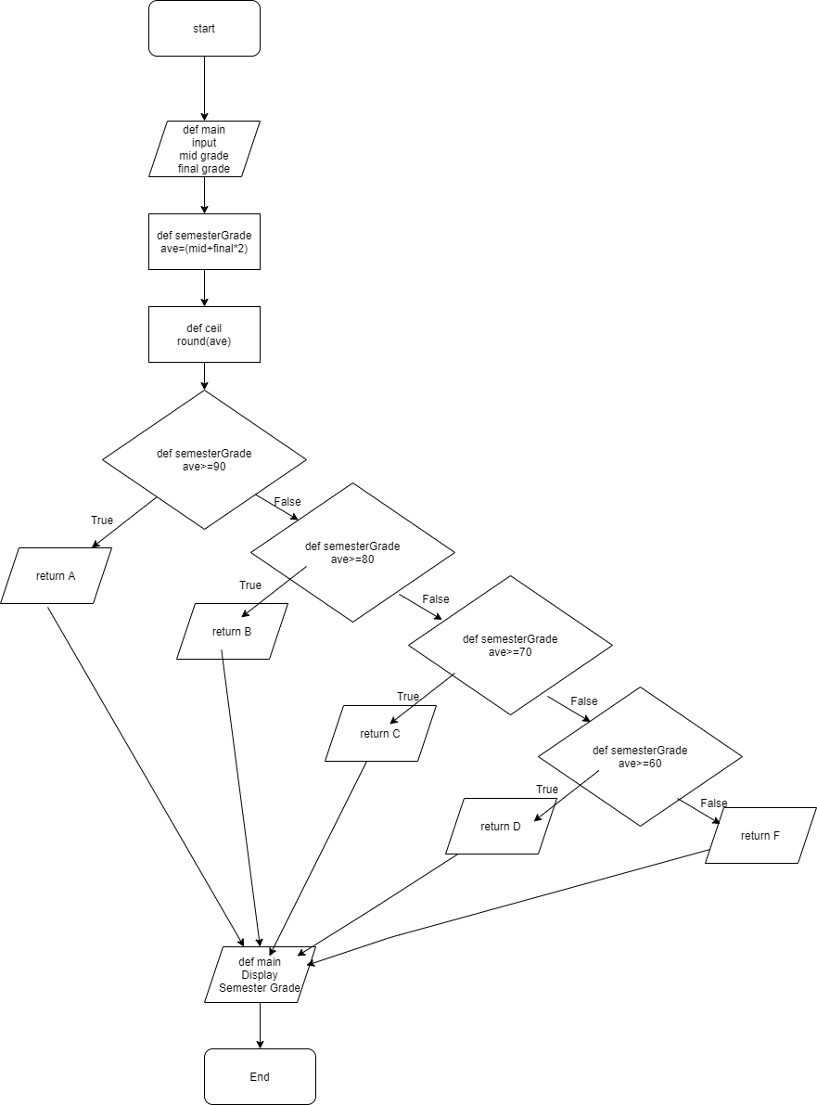

2. Result explanation

Program receives midterm and final exam grade using the input of 'main' function.

These grades go to the function 'semesterGrade' and are calculated by the mean calculation to produce the result 'ave'. Afterwards, 'ave' goes to the ceil function and is calculated by rounding calculations to produce the resulting value 'ave2'. "Ave2" goes back to the "semester grade" function and returns "A" for 90 points or more , "B" for 80 points or more, "C" for 70 points or more, "D" for 60 points or more, and "F" for other points by using ‘if’.

 The returned results come back to the "print" part of the "main" function, where one of A, B, C, D, and F enters "format" and, consequently, shows performance.